**ID3 algorithm**

**Code**

import math

import csv

def load_csv(PlayTennis):

   lines=csv.reader(open(PlayTennis,"r"));

   dataset = list(lines)

   headers = dataset.pop(0)

   return dataset,headers

class Node:

  def __init__(self,attribute):

    self.attribute=attribute

    self.children=[]

    self.answer=""

def subtables(data,col,delete):

    dic={}

    coldata=[row[col] for row in data]

    attr=list(set(coldata))

    counts=[0]*len(attr)

    r=len(data)

    c=len(data[0])

    for x in range(len(attr)):

     for y in range(r):

      if data[y][col]==attr[x]:

         counts[x]+=1

    for x in range(len(attr)):

      dic[attr[x]]=[[0 for i in range(c)] for j in range(counts[x])]

      pos=0

      for y in range(r):

        if data[y][col]==attr[x]:

          if delete:

            del data[y][col]

          dic[attr[x]][pos]=data[y]

          pos+=1

    return attr,dic

def entropy(S):

    attr=list(set(S))

    if len(attr)==1:

        return 0

    counts=[0,0]

    for i in range(2):

      counts[i]=sum([1 for x in S if attr[i]==x])/(len(S)*1.0)

    sums=0

    for cnt in counts:

      sums+=-1*cnt*math.log(cnt,2)

    return sums

def compute_gain(data,col):

  attr,dic = subtables(data,col,delete=False)

  total_size=len(data)

  entropies=[0]*len(attr)

  ratio=[0]*len(attr)

  total_entropy=entropy([row[-1] for row in data])

  for x in range(len(attr)):

      ratio[x]=len(dic[attr[x]])/(total_size*1.0)

      entropies[x]=entropy([row[-1] for row in dic[attr[x]]])

      total_entropy-=ratio[x]*entropies[x]

  return total_entropy

def build_tree(data,features):

    lastcol=[row[-1] for row in data]

    if(len(set(lastcol)))==1:

       node=Node("")

       node.answer=lastcol[0]

       return node

    n=len(data[0])-1

    gains=[0]*n

    for col in range(n):

       gains[col]=compute_gain(data,col)

    split=gains.index(max(gains))

    node=Node(features[split])

    fea = features[:split]+features[split+1:]

    attr,dic=subtables(data,split,delete=True)

    for x in range(len(attr)):

      child=build_tree(dic[attr[x]],fea)

      node.children.append((attr[x],child))

    return node

def print_tree(node,level):

    if node.answer!="":

      print(" "*level,node.answer)

      return

    print(" "*level,node.attribute)

    for value,n in node.children:

      print(" "*(level+1),value)

      print_tree(n,level+2)

def classify(node,x_test,features):

    if node.answer!="":

      print(node.answer)

      return

    pos=features.index(node.attribute)

    for value, n in node.children:

      if x_test[pos]==value:

        classify(n,x_test,features)

'''Main program'''

dataset,features=load_csv("PlayTennis.csv")

node1=build_tree(dataset,features)

print("The decision tree for the dataset using ID3 algorithm is")

print_tree(node1,0)

testdata,features=load_csv("PlayTennis.csv")

for xtest in testdata:

  print("The test instance:",xtest)

  print("The label for test instance:",end=" ")

  classify(node1,xtest,features)

**OUTPUT**

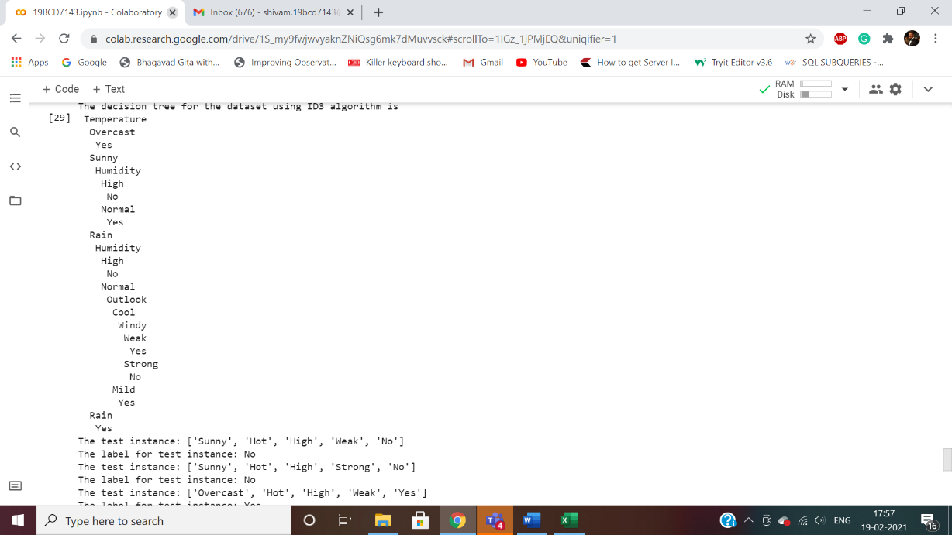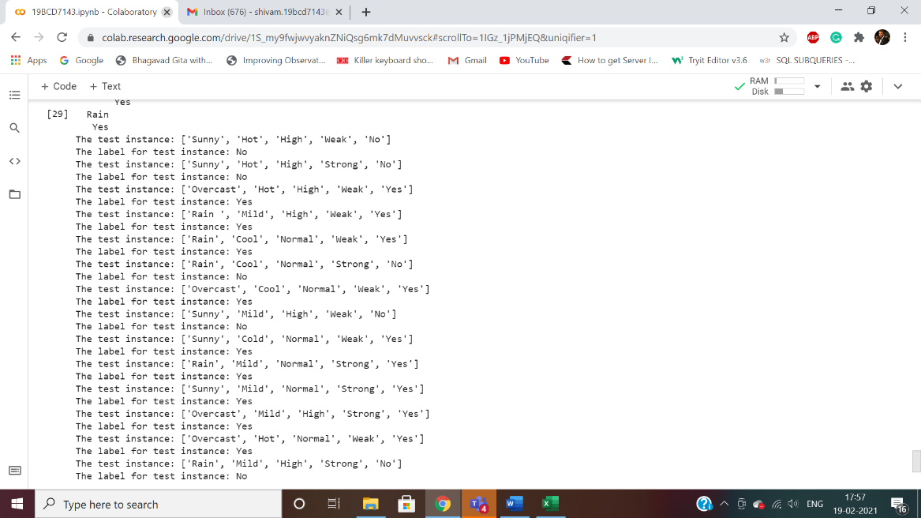

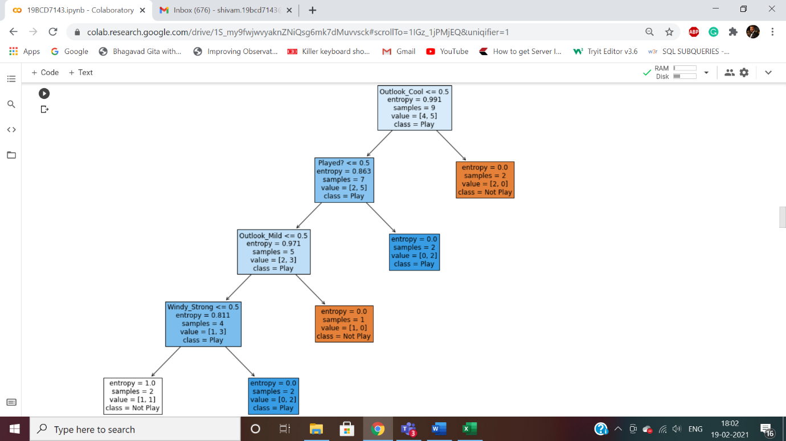

**Observations**

ID3 determines the information gain for each candidate attribute (i.e., Outlook, Temperature, Humidity, and Wind), then selects the one with highest information gain. S denotes the collection of training examples. Outlook is selected as the decision attribute for the root node, and branches are created below the root for each of its possible values (i.e., Sunny, Overcast, and Rain).

Gain(S,Outlook)=0.246

Gain(S,Humidity)=0.151

Gain(S,Wind)=0.048

Gain(S,Temperature)=0.029

**Conclusion**

So, decision tree algorithms transform the raw data into rule based mechanism. They can use nominal attributes whereas most of common machine learning algorithms cannot. However, it is required to transform numeric attributes to nominal in ID3. Besides, its evolved version C4.5 exists which can handle nominal data. Even though decision tree algorithms are powerful, they have long training time. On the other hand, they tend to fall over-fitting. Besides, they have evolved versions named random forests which tend not to fall over-fitting issue and have shorter training times.